Section 5.2 Finding the growth factor

Exponential equations can be used to model anything where how fast something is growing depends on how much there is. Things like money growing at compound interest. When you have more money, you make more money.

Population growth also tends to be exponential. This is because populations tend to grow by fixed percentages. Larger populations add more people that smaller populations do.

The population of the world grew from about 3.9 billion people in 1970 to about 6.3 billion people in 2003. Let’s try to find an exponential equation of the form
.
that can be used to model the population growth of the world.

Let t be the time, in years, since 1970 and let P be the population of the world, in billions of people. Since we chose 1970 to represent t = 0, we already know the starting value. It is the value of P that corresponds to t = 0, or 3.9. The only thing that we don’t know here is the growth factor.

So, if we fill in the parts that we know in our equation, we have 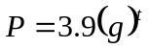, where g is the growth factor that we still need to figure out.

We have the information that we need in order to find the growth factor. We know that by 2003, the population of the world had grown to 6.3 billion people. Since 2003 is 33 years after 1970, we know that when t = 33, P = 6.3. Fill these values into the equation for t and P and we will have an equation that we can solve for g.
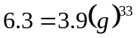.
To solve this equation, first divide both sides of the equation by 3.9 to get
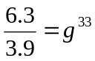.
Now we have to undo the 33rd power. We undo the 33rd power with the 33rd root. This is done by raising both sides of the equation to the 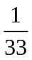 power.
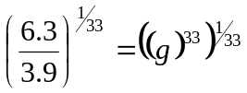
On the right side of the equation the 33 and the multiply together to get 1 so we have
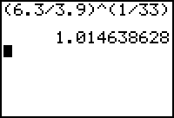
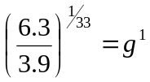, or just 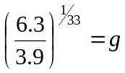.
There, we have solve the equation for g. Now haul out the calculator to find a decimal approximation for g.
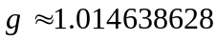. Fill this number into the equation and we have the equation that models the population growth of the world since 1970, 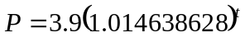.

Let’s look back and figure out what we just did. We wrote an exponential equation after being given two points on its graph.

First we named the variables. Then filled in what we knew in the standard equation. Most of our work was done in figuring out what the growth factor was. We came up with the calculation
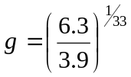
3.9 was the beginning value of the dependent variable, 6.3 was the ending value of the dependent variable and 33 was the number of years it took for 3.9 to grow up to be 6.3. We can generalize this to get a formula to use for calculating the growth factor.

If the dependent variable in an exponential relationship grows from a value of P to a value of A while the independent variable changes by t, the growth factor is
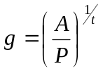

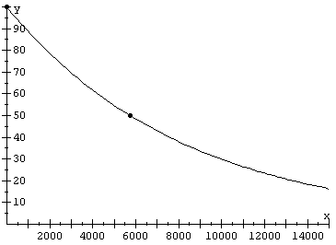
Example 5.2.1: Radioactive substances decay exponentially. In other words, if time is the independent variable, and the amount of a radioactive substance remaining is the dependent variable, the relationship between these variables is governed by an exponential equation. Carbon-14 is a radioactive substance that plays an important role in archaeology. Carbon-14 has a half-life of about 5730 years. That is, an amount of Carbon-14 will decay to half of that amount in 5730 years. You have been issued 100 grams of Carbon-14. It is going to decay exponentially. Find an exponential equation that shows the relationship between the amount of Carbon-14 remaining and time.

Solution: Let t be the time, in years, since you were issued the Carbon-14 and let C be the amount of Carbon-14 remaining. We know that when t = 0, C = 100. We also know one other extremely important fact about Carbon-14. We know the half-life. In 5730 years, half of the original amount will be gone. That means that when t = 5730, C = 50. This should give us enough information to write our equation.

Start from the basic template

The independent variable is t, the dependent variable is C and the starting value is 100. Fill these in to get the equation
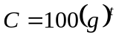.
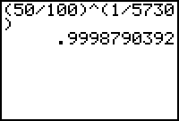
Now all we need to do is find the growth factor by using the equation . It took 5730 years for 100 grams to shrink down to 50 grams. Fill in the blanks to get 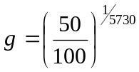 and haul out your calculator. It is important that we don’t round this growth factor off too much. The growth factor is a number that we are going to be raising to huge powers. In other words it will be multiplied times itself many, many times. That means that any error we introduce by rounding will be compounded.

Here is our equation 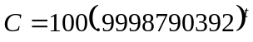. ■

Example 5.2.2: Beth has $10,000 to invest. She wants this money to double in value in 12 years. If the money grows exponentially, what growth factor is necessary?

Solution: She wants $10,000 to grow to $20,000 in 12 years. That’s all we need to know to use our growth factor formula . 10,000 is the starting value, $20,000 is the ending value and t = 12 years is the amount of time it took. 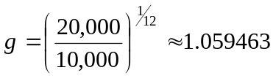■

Example 5.2.3: What is the growth rate of Beth’s money in the previous example?

Solution: The relationship between the growth rate and the growth factor is summarized in the equation 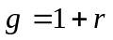. Here 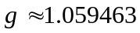, so 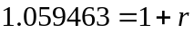 and we can solve for 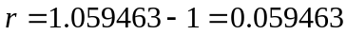. So her money needs to have a growth rate of a little more than 5.9%. ■

Example 5.2.4: A newspaper publisher has bought a new press for $350,000. The press has a useful life of 20 years at which time it will have a scrap value of $10,000. The depreciation of the press over this period of time is going to be done exponentially. What is the growth factor?

Solution: $350,000 is the starting value, $10,000 is the ending value and t = 20 is the number of years. The growth factor is 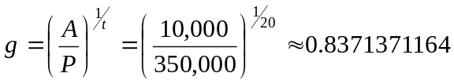. Does it make sense that this number is less than 1? ■

Example 5.2.5: For the press in the previous example, what percentage of the value is lost every year?

Solution: We found the growth factor 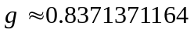. That represents the amount value that the machine keeps each year. We want to know what portion of the value is lost every year. Remember the relationship between the growth rate and the growth factor, . 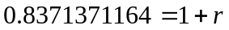, . Turn this into a percentage and we have our answer. The machine loses about 16.3% of its value each year. ■

Example 5.2.6: A population of bacteria starts growing in a jar. The population doubles every day. After 30 days, they discover that they have used up all the room in the jar.
a) When was the jar only half full of bacteria?
b) Some trailblazing bacteria set out and colonize 3 other jars that are nearby and are the same size. For how many more days will this give the bacteria enough room to live?

Solution: a) It is tempting to say that since the jar was full after 30 days, it was half full after 15 days, but this is wrong. The population is growing exponentially, not linearly and it is doubling every day. Since the jar is full after 30 days it must have been half full just the day before. It was half full after 29 days.
b) Since they take up one jar after 30 days, they will take up 2 jars after 31 days and 4 jars after 32 days. The 3 new jars will just give them enough room for 2 more days. It’s time for some bleach. ■

Example 5.2.7: In 1970 the population of the Algeria was 13.9 million. In 1980 the population had grown to 18.8 million people. Assume that the population is growing exponentially and find an equation that shows the population of Algeria t years after 1950.

Solution: This is different than the stuff we have done up to this point. Let t be the number of years since 1950 and P the population of Algeria, in millions of people. Previously, we have been given the starting value. But here, the starting value would be the population of Algeria in 1950 and that’s not one of the points that we have been given. So, at this point we know when t = 20, P = 13.9 and when t = 30, P = 18.8. That is enough to find the growth factor. The population grew from 13.9 million to 18.8 million in 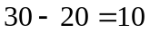 years, so 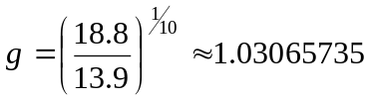. So our standard equation looks like 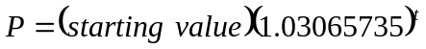.

Now, to find the starting value, we can take either of the two points that we know and fill their values in for t and P. That will give us an equation to solve for the starting value. For example, fill in 20 for t and 13.9 for P to get
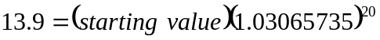
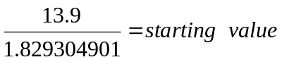
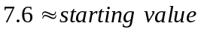
So our equation becomes  

